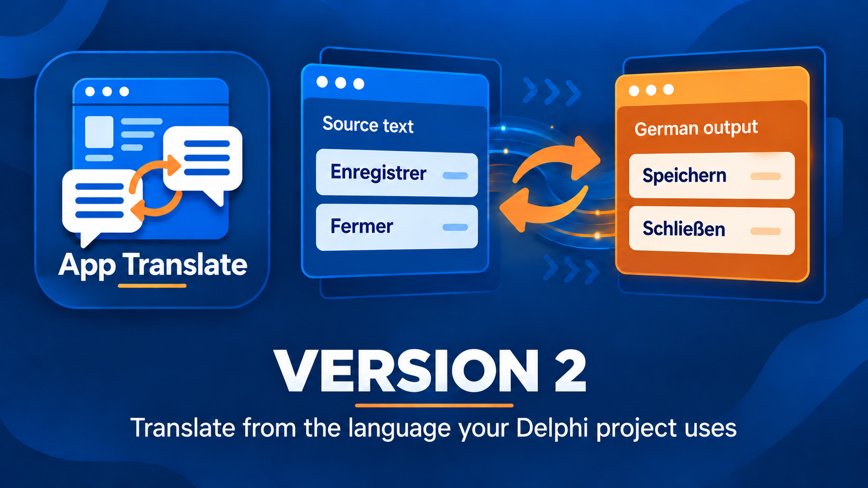

Delphi App Translation Studio Setup Wizard Guide
A guided first translation from project to language pack
Version 2 | Last changed 7 October 2026

Contents

What the Wizard does 3
Step 1 — Welcome 3
Step 2 — Delphi Project 3
Step 3 — Deployment 3
Step 4 — Languages 4
Step 5 — Translation Service 4
Step 6 — Scan Project 4
Step 7 — Review and Authorize 5
Step 8 — Process and Finish 5
After the Wizard 5

What the Wizard does
The Setup Wizard takes a saved Delphi project through one first translation. It scans text, makes a Safety Backup, creates an editable translation catalog, lets you inspect the result, and prepares offline language packs. It does not silently edit the project's Pascal, DPR, DPROJ, DFM, or FMX files. Open Run Setup Wizard from the start screen. Use Maintenance Studio later to add or revise languages.
A source language is the language already present in the saved project. A target language is the language you want to add. A development catalog is your editable translation work; a runtime pack is the validated file the running application uses. Saving a catalog alone does not deploy a pack.

Before you start
- Save all target-project files in RAD Studio and close the running target application.
- Have the project's .dproj or .dpr file ready and know the language used by its text.
- Have a DeepL or Google Cloud Translation key if you will request automatic translation. Requests may incur charges.
- Decide whether there are separate application folders, such as an installed copy or portable copy, that also need packs.

Step 1 — Welcome
Read the opening explanation, then choose Next. The setup steps remain visible on the left. You can revisit earlier choices before final processing starts.

Step 2 — Delphi Project
Choose the saved .dproj or .dpr file. Confirm the project identity and framework. The workflow choice offers Automatic (Recommended), Create New Translation, and Update Existing Translation. Automatic uses saved translation work when appropriate. Choose an explicit mode when you need to start a new catalog or update a known one. Next proceeds to Deployment.

Step 3 — Deployment
Review the build-output folders that the Wizard found. Add a separate application folder if you also run or distribute another copy. An added folder is a pack destination, not a replacement for the project itself. Executable replacement is a separate choice and should be authorized only when intended. Packs for the source and target language are stored in Localization\Languages alongside each updated executable; the project also keeps a Localization\Languages copy for later builds.

Step 4 — Languages
Choose the language actually written in the saved project, then choose a different target language. For a first test, one target is easy to inspect. Additional targets can be added later in Maintenance Studio without reselecting earlier languages.

Step 5 — Translation Service
Select DeepL or Google Cloud Translation. For DeepL, choose API Free or API Pro to match the key you own. Enter a key or use a securely saved key, then choose Test Connection. Check the result before moving on. This service creates draft text; review is still a human decision.

Step 6 — Scan Project
Choose Scan Project. The Wizard reads saved form text and source strings and displays the number of unique entries, raw occurrences, and equivalent duplicates. Read the sample list. If it shows the wrong project or source language, go back before processing. Scan time varies with project size; a high count is not by itself an error.
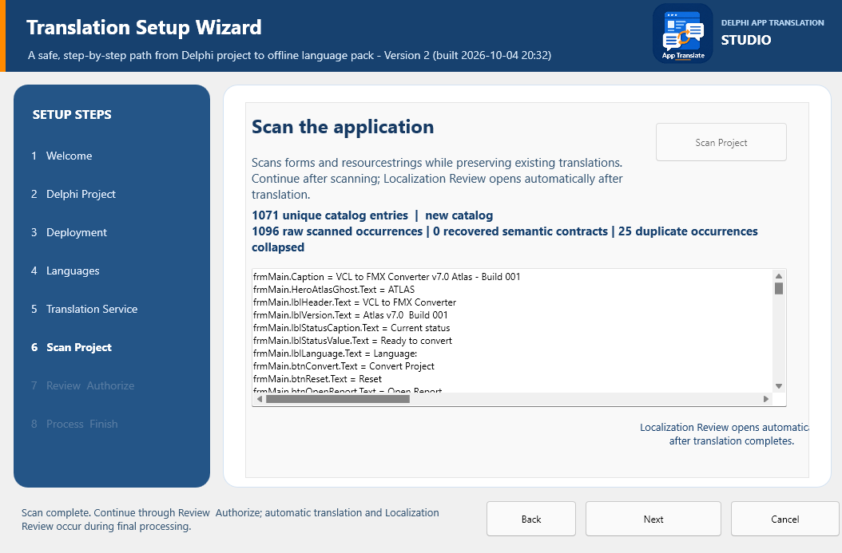
Scan results show the text found in the saved project. Use Next only after checking that the project and language are correct.

Step 7 — Review and Authorize
Review the project, languages, service, integration plan, and destinations. Confirm the safety conditions: save the target files and close any running target application. The Wizard requires a ZIP Safety Backup before it changes its own translation output. Begin Final Processing starts the backup and then the translation, review, and export sequence. Do not begin until these choices are correct.

Step 8 — Process and Finish
The progress page records the work in order. The backup can take a few minutes on a large project. You may cancel while backup runs. When Localization Review opens, inspect terminology and any proposed layout adjustments. Close that review window to let final validation, pack export, kit preparation, builds, and deployment continue. During processing, navigation and manual deployment are unavailable.
When processing succeeds, the finish page offers Add more languages, Open Maintenance, Return to start, and Deploy to App Folder for a separate folder you choose. The latter is enabled only after successful processing. If you add languages later, validate and export the new set from Maintenance Studio. Rebuild before deploying and platform/configuration choices are provided for a later manual deployment when applicable.

After the Wizard
Open the exact executable you intend to test. Confirm its Localization\Languages folder contains the source and target packs. If the target application has not yet been connected to the DAT runtime components, complete that integration in RAD Studio before expecting the language selector to work. The Engineering Guide explains the editable component setup. Test switching to the target language and back, then inspect real forms and messages. A saved catalog or successful service request is not a substitute for this running-app check.
If processing stops, read the last progress message, correct the cause, and resume from the appropriate step. From the start screen, Recover from Safety Backup restores a selected Studio ZIP to a new empty folder; it does not overwrite the original project.

